*Monofilament Burnwire Deployment System Performance in a Low-Pressure Environment*

By: Shivani Nadarajah

Paijanne Jones

John George

Calvin Young

Justin Burris

ME 411 - Engineering Measurements and Instrumentation

Dr. Derek Tretheway

March 19th 2018

**Introduction**

The deployable antenna systems of Oregon’s Small Satellite Project (OreSat) are held in their stowed configurations by nylon monofilament lines and released after a large voltage drop across a small resistor, or burn wire, generates enough heat to cause the nylon line to fail in tension, releasing the spring-loaded antennas to their desired positions. A properly designed system will withstand the vibrational loads of a rocket launch while requiring a minimal amount of energy to deploy.

The experiment was designed to analyze three of the burn wire system’s key input variables: diameter of the monofilament, value of the resistor, and ambient pressure. In order to establish the connection between variables and distinguish the level of importance, the results are analyzed by looking at the total energy used during each experiment. This value also captures a number of other important parameters, including: current, voltage across the resistor, and time to failure. By understanding the sensitivity to each input variable and the interactions between them, the team will make well-informed decisions when designing the final flight system.

This report is intended to document and analyze the results of this initial burn wire experimentation. Investigations into sources of experimental error and discrepancies in the data are presented as a platform to motivate future experimentation.

**Experiment and Methods**

The experimental procedure began with a resistor secured to the testing apparatus, and a fishing line tied between two eyelets attached to a spring-loaded mechanism. Shown in Fig. 1, this mechanism was designed to hold the monofilament in tension, simulate the load caused by the antenna systems, and keep the line in contact with the resistor. Next, the system’s microcontroller was powered, and if required by the run, the entire device was placed inside a vacuum chamber, as seen in Fig. 2. A serial command initiated the experiment by running current through the resistor. Time and voltage data were then logged as the resistor heated and began to melt through the monofilament line. Once the line was severed, the spring-loaded mechanism snapped shut, completing a circuit, which then signaled the microcontroller to interrupt the main loop and shut off current to the resistor. The monofilament and resistor were then replaced and the experiment was repeated using the next set of required interactions.

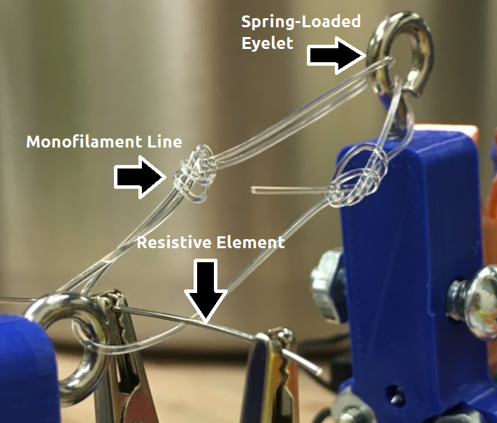

**Figure 1**: Alligator clips hold a resistive element against a monofilament line. The eyelet on the right is spring-loaded with a conductive pad used to send a signal to the microcontroller upon completion of the experiment.

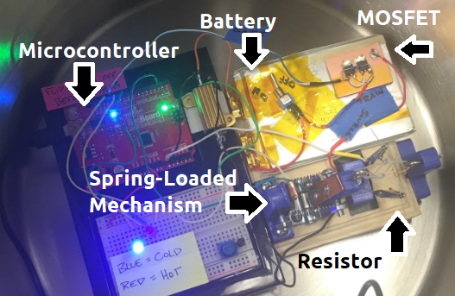

**Figure 2**: The entire testing apparatus is configured and placed in a vacuum chamber. The experiment is triggered via a serial connection which also transfers the data to be logged on an external computer.

Simulating the eventual flight configuration, a 3.7 volt single-cell lithium polymer battery was used to power the resistive element. A microcontroller monitored the voltage drop for both the heated resistor and the inline shunt used to calculate the current flowing through the circuit shown in Fig. 3. The shunt voltage was probed using a Kelvin connection to achieve a more accurate measurement.

Time and voltage data were logged over a serial line which took an average of 10 readings per second, yielding a temporal resolution of approximately 100 milliseconds. The voltage readings were taken on a 5 volt, 10-bit analog-to-digital converter onboard the microcontroller. The resistor’s voltage reading was in the range of 3 to 4 volts while the shunt’s lower resistance yielded a range on the order of 0.5 to 1 volt.

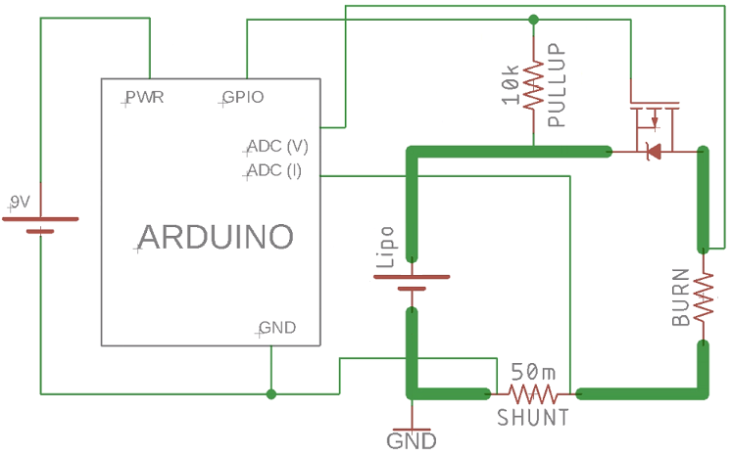

**Figure 3**: An Arduino logs time and voltage data while using a p-channel MOSFET to control the main circuit. The value of the main resistive element (labeled BURN) is one of the primary factors in the experiment.

A two-level, full factorial experiment was designed to measure the effects of each variable and any potential interactions between them on the outcomes of the experiment. With three factors being measured, this resulted in a 2^3 experiment with 8 runs per replicate.

**Table 1**: Two levels were used for each of the three factors in the experimental design.

|  |  |  |
| --- | --- | --- |
| **Factor** | **Low** | **High** |
| Pressure | 17 kPa | 101 kPa |
| Monofilament Diameter | 0.37 mm | 0.70 mm |
| Resistance | 2 Ω | 3 Ω |

A total of three full replicates were conducted with a randomized design matrix run order. Details of the experimental design are laid out in Table 1A (see Appendix). Both energy (in Joules) and time (in seconds) were used as performance metrics for the experiment.

With three replicates of the experiment, there were 23 degrees of freedom for the analysis of variance (ANOVA). Each factor provides one degree of freedom due to having two settings for each. Interaction terms each give one additional degree of freedom. A further 16 degrees of freedom are gained through residuals or error gained through the three replicates. These 23 degrees of freedom are sufficient to consider the ANOVA valid.

**Results**

First, the voltage drop across the resistor and shunt are calculated using

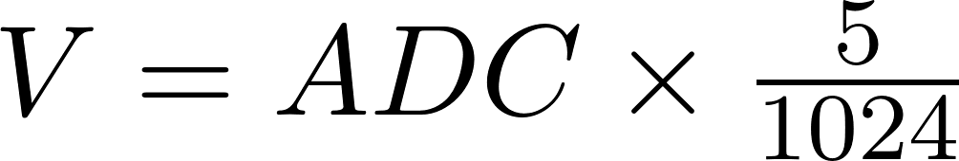 (1)

where  is the signal of the analog-to-digital converter. Next, current is calculated from the shunt’s voltage drop using Ohm’s law

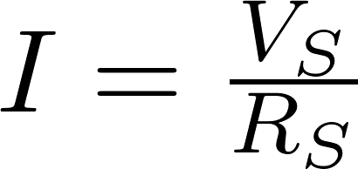 (2)

where 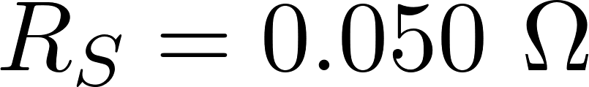 is the shunt resistance, and *Vs* is the shunt voltage. Finally, the amount of energy consumed by the circuit is calculated from

 (3)

where  is the length of time that the current was supplied to the resistor.

The microcontroller provided instantaneous readings of voltage, which are theoretically stable, with a nominal drop as the battery loses charge over time. By using the averages of those readings we calculate the energy consumption using Equation (3) above. If the voltage or current changed appreciably over time, the readings would have been integrated instead.

At first glance, the results showed more variation than expected. Since each run was replicated a total of three times, advanced analysis was not required to notice inconsistencies in the data. For example, one run with low pressure, high diameter, and high resistance had a failure time that was twice that of another run with the same settings (standard runs 12 and 20 in Table 1A). While differences in other pairwise comparisons are less extreme, the data is quite noisy.

Analysis shows that the diameter of the monofilament is the most important factor for controlling both the time to cut and the energy requirement. Resistance is also a very important factor in the time to cut, though it does not have a significant impact on the total energy required to do so. Figures 4 and 5 display the mean plots for each of these independent variables.

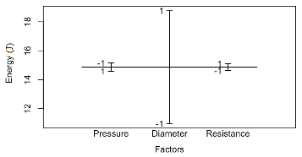

**Figure 4**: Design of experiment mean plot with energy consumption as the dependent variable. Monofilament diameter is the most important variable. Both resistance and pressure are relatively unimportant factors.

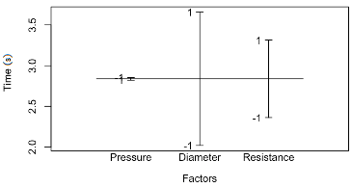

**Figure 5**: Design of experiment mean plot with time to failure as the dependent variable. Pressure has little-to-no effect, while the diameter of monofilament and the heating element resistance both have a large effect on the experiment.

The mean plots in Fig. 4 and 5, clearly show the relative sensitivity for each of the dependent variables of the three factors controlled in the experiment. There also appears to be an important interaction between pressure and monofilament diameter as shown in the ANOVA results in Table 2A.

Analyzing the results of the 8th run (and its replicates) in Table 1A shows that setting all factors to their high values results in the longest time to cut, with an average value of 4.64 seconds. The next longest times are achieved by setting both resistance and diameter high, and pressure set low, yielding an average value of 4.19 seconds, illustrating that the pressure has a negligible effect on time as suggested in Fig. 5.

When considering energy as the dependent variable, high settings for all factors also result in the largest value at 21.31 joules. The second highest energy value once again results from a low pressure setting along with high monofilament diameter and high resistor values, yielding 18.92 Joules. Only slightly less is the configuration of high pressure, high diameter and low resistance, with a value of 18.67 Joules. Once again, this demonstrates that pressure and resistance have a very weak effect on the energy required, as in accordance with the mean plot in Fig. 4.

**Sources of Error**

A number of sources of experimental error have been identified. Variations in air pressure and ambient temperature were not controlled for, however, in a climate-controlled laboratory the magnitude of the fluctuations should not be significant. The vacuum chamber used to conduct low-pressure experimental runs was manually controlled using a mechanical gauge which led to uncertainty in the gauge and inconsistencies between runs, likely accounting for variations around 5 kilopascals.

The shunt had a measured voltage of between 0.5 and 1 volts which did not fully saturate the 5 volt analog-to-digital converter of the microcontroller. A better-planned experiment would have included an operational amplifier with a gain of a little less than 5 in order to increase the resolution of the shunt’s readings.

The through-hole resistors had nominal values of 2 and 3 ohms with average measured values of 2.09 and 3.10 ohms, and standard deviations of 0.08 and 0.13 ohms, respectively. This range in values contributed 5 to 10% of the inaccuracies in the voltage readings which propagated through the experimental results. Since the average values are above nominal, the experimental results are skewed higher.

Perhaps the largest and least-understood source of error results from the uncontrolled tension in the monofilament. Each line was tied by hand which led to variations in length of up to 5 millimeters. The spring force used to keep the line in tension is a function of the line’s length - as a result, there was an uncontrolled variation in that tension. Shorter lines were under higher tension which will have caused them to fail earlier than longer lines. The sensitivity to this variation and the magnitude to which it skewed the results is unknown.

**Summary**

While the resistance of the heating element is important to consider if time is an issue, the results clearly indicate that the diameter of the monofilament line is the most decisive factor in the burn wire mechanism. Knowing this provides the engineering team with information to begin the process to optimize the time and energy requirements for proper deployment, while also maintaining a monofilament diameter that accommodates the design’s mechanical criteria.

The full factorial design of experiments provided an informative first look at the system’s sensitivity to the three variables and their interactions, but increased control and experimental precision is needed for stronger conclusions; there is too much variation between trial runs of the same settings. An additional experiment should also be conducted to determine the influence of the line tension on time to failure; the inconsistencies in the data presented in this report might be alleviated with further analysis.

**Appendix**

A full factorial experiment was designed and run to test three factors that may or may not affect the energy or time to cut a nylon monofilament line. The experimental settings, analysis and raw data are included.

**Table 1A**: Three replicates of a two level, three factor, full-factorial design. Both energy (in joules) and time (in seconds) were used as performance metrics of the experiment. The run order of each trial was randomized to account for factors such as battery drainage over time.

|  |  |  |  |  |  |  |  |
| --- | --- | --- | --- | --- | --- | --- | --- |
| 1st Replicate: | Standard Order | Run Order | Pressure | Diameter | Resistance | Energy (J) | Time (s) |
|  | 1 | 1 | -1 | -1 | -1 | 13.81 | 1.936 |
|  | 2 | 5 | -1 | -1 | +1 | 13.94 | 3.222 |
|  | 3 | 2 | -1 | +1 | -1 | 12.39 | 1.999 |
|  | 4 | 8 | -1 | +1 | +1 | 19.65 | 4.333 |
|  | 5 | 3 | +1 | -1 | -1 | 13.44 | 2.186 |
|  | 6 | 6 | +1 | -1 | +1 | 7.62 | 1.749 |
|  | 7 | 7 | +1 | +1 | -1 | 21.31 | 3.135 |
|  | 8 | 4 | +1 | +1 | +1 | 19.59 | 4.370 |
| 2nd Replicate: | 9 | 9 | -1 | -1 | -1 | 17.06 | 2.622 |
|  | 10 | 13 | -1 | -1 | +1 | 10.35 | 2.136 |
|  | 11 | 10 | -1 | +1 | -1 | 19.36 | 3.086 |
|  | 12 | 16 | -1 | +1 | +1 | 13.61 | 2.898 |
|  | 13 | 11 | +1 | -1 | -1 | 8.49 | 1.450 |
|  | 14 | 14 | +1 | -1 | +1 | 7.83 | 1.761 |
|  | 15 | 15 | +1 | +1 | -1 | 19.33 | 3.085 |
|  | 16 | 12 | +1 | +1 | +1 | 21.67 | 4.643 |
| 3rd Replicate: | 17 | 17 | -1 | -1 | -1 | 7.87 | 1.237 |
|  | 18 | 21 | -1 | -1 | +1 | 13.53 | 2.823 |
|  | 19 | 18 | -1 | +1 | -1 | 16.76 | 2.597 |
|  | 20 | 24 | -1 | +1 | +1 | 23.50 | 5.368 |
|  | 21 | 19 | +1 | -1 | -1 | 10.37 | 1.550 |
|  | 22 | 22 | +1 | -1 | +1 | 7.26 | 1.550 |
|  | 23 | 23 | +1 | +1 | -1 | 15.37 | 3.459 |
|  | 24 | 20 | +1 | +1 | +1 | 22.65 | 4.919 |

**Table 2A**: Analysis of variance table with the response variable being energy required to burn the nylon monofilament. Diameter is the most important variable, the pressure:diameter interaction as well as the diameter:resistance interaction are also relevant.

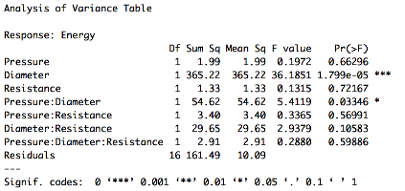

**Table 3A**: Analysis of variance table with the response variable being time required to burn the nylon monofilament. Diameter has the most effect on the response time. Diameter of monofilament is the most important factor.

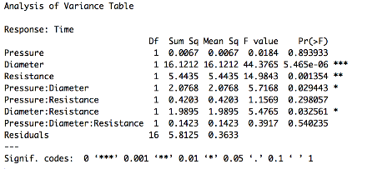

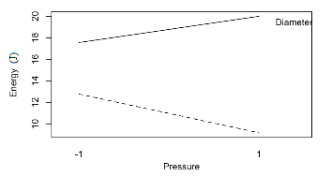

**Figure 1A:** Interaction plot showing the interactions between diameter of monofilament and pressure when the dependent variable considered is energy. There is no interaction between filament diameter and pressure in this case.

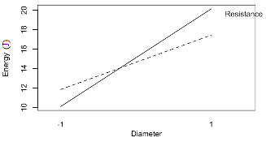

**Figure 2A:** Interaction plot showing the interactions between diameter of monofilament and resistance when the dependent variable considered is energy. There is an interaction between these two factors.

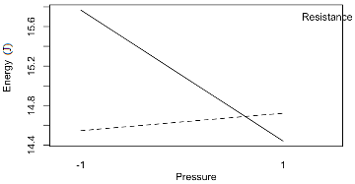

**Figure 3A:** Interaction plot showing the interactions between diameter of monofilament and pressure when the dependent variable considered is energy. There is an interaction between the pressure and resistance.

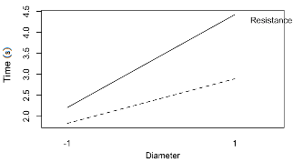

**Figure 4A:** Interaction plot showing the interactions between diameter of monofilament and resistance when the dependent variable considered is time to melt the wire. There is not an interaction between the diameter and resistance.

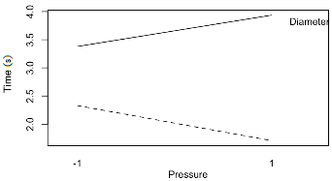

**Figure 5A:** Interaction plot showing the interactions between diameter of monofilament and resistance when the dependent variable considered is time to melt the wire. There is not an interaction between the diameter and pressure.

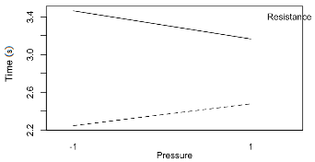

**Figure 6A:** Interaction plot showing the interactions between pressure and resistance when the dependent variable considered is time to melt the wire. There is not an interaction between the diameter and resistance.